CASE STUDY TO UNDERSTAND A DATASET BASIC

Category: Machine learning

**Project Description:**

In this project, I need to specify which type of machine learning is used for the given datasets.

1. Bikesharing Dataset
2. Boston Dataset
3. Diabetes Dataset

For the above data sets, I observed that the

For the bikeshare data set, we use the classification technique which is a supervised learning model. We classify the data set by the

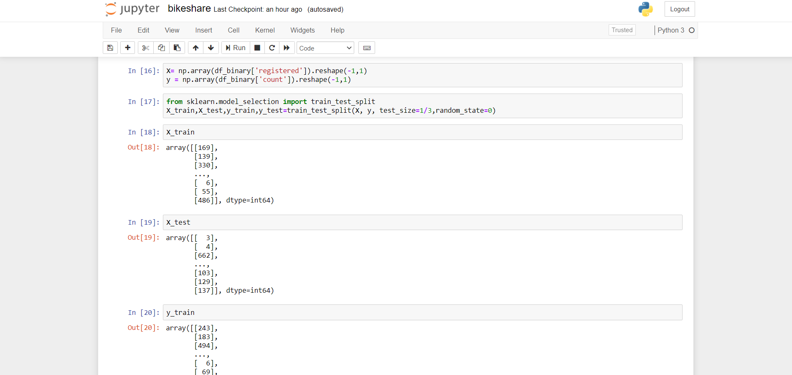

After this trained and tested to get the prediction of how many are the count and registered in the bikeshare data set.

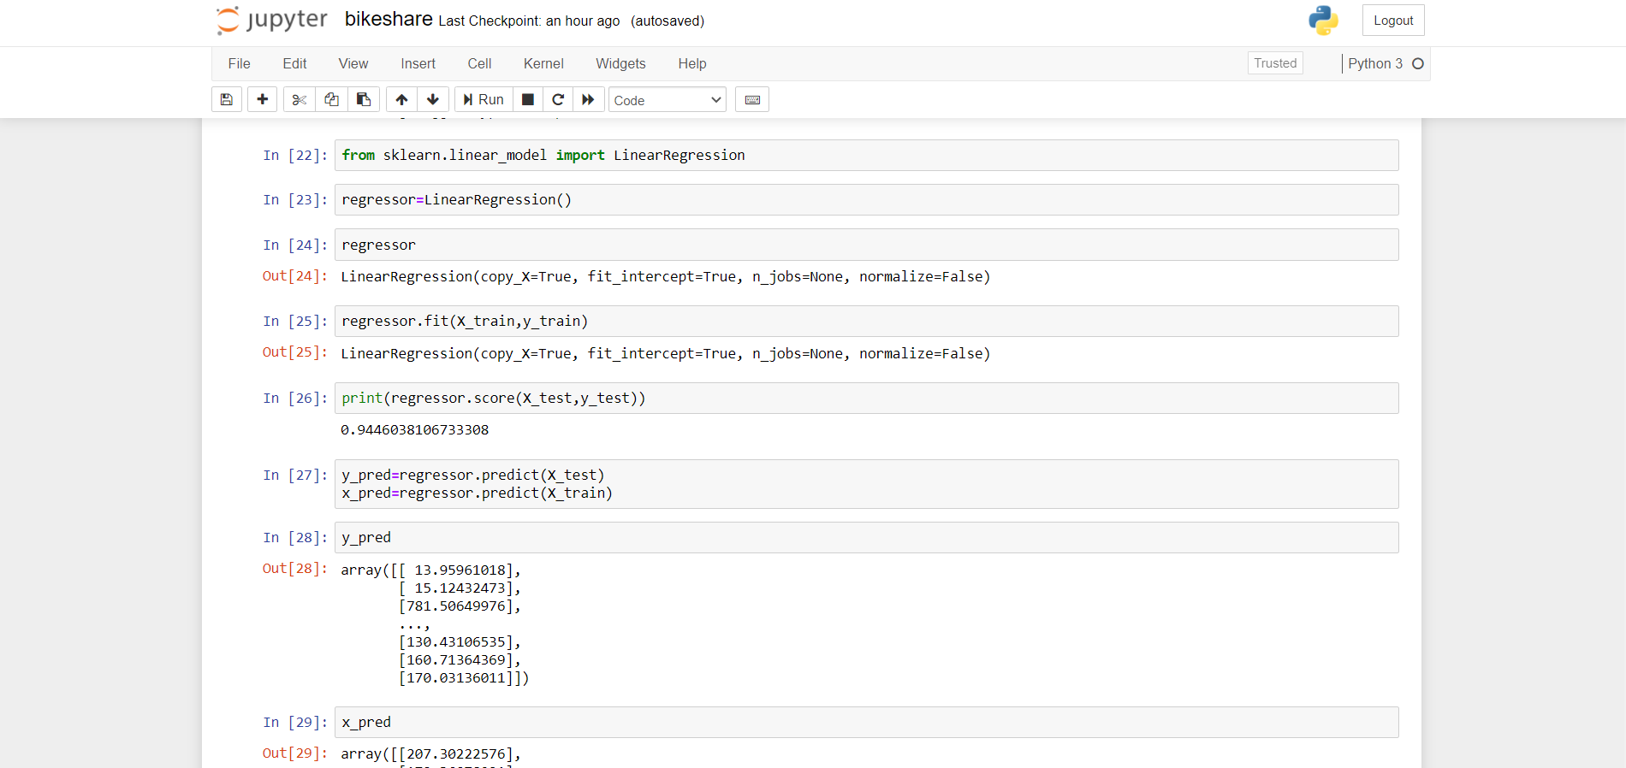

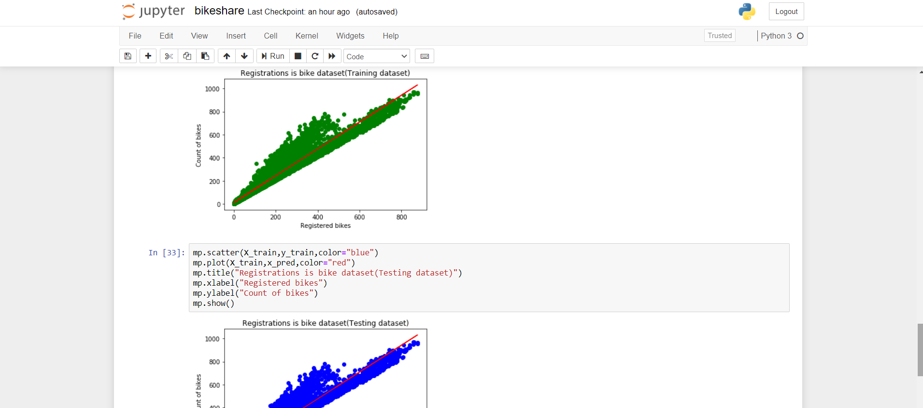

For the boston data set, we use the regression technique which is a supervised learning model. We classify the data set by the

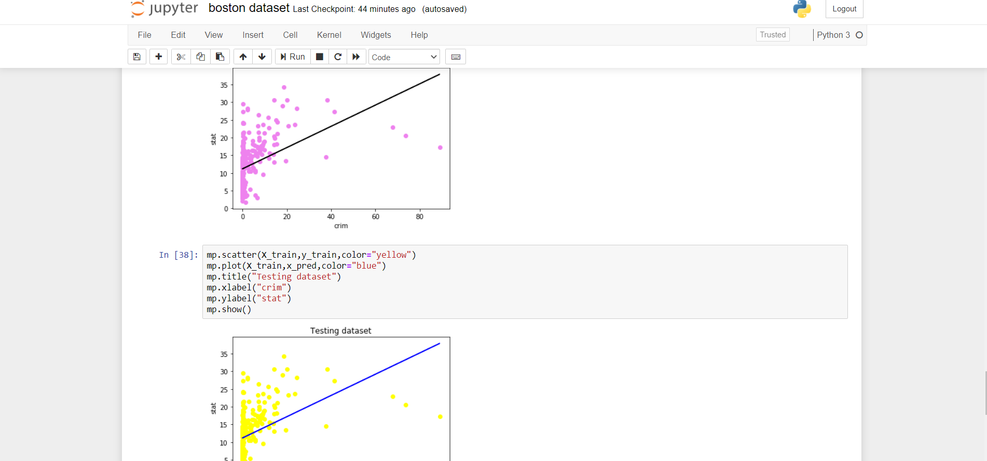

* for the diabetes dataset, I used the logistic regression. The train accuracy is 78% and test accuracy is 76%.

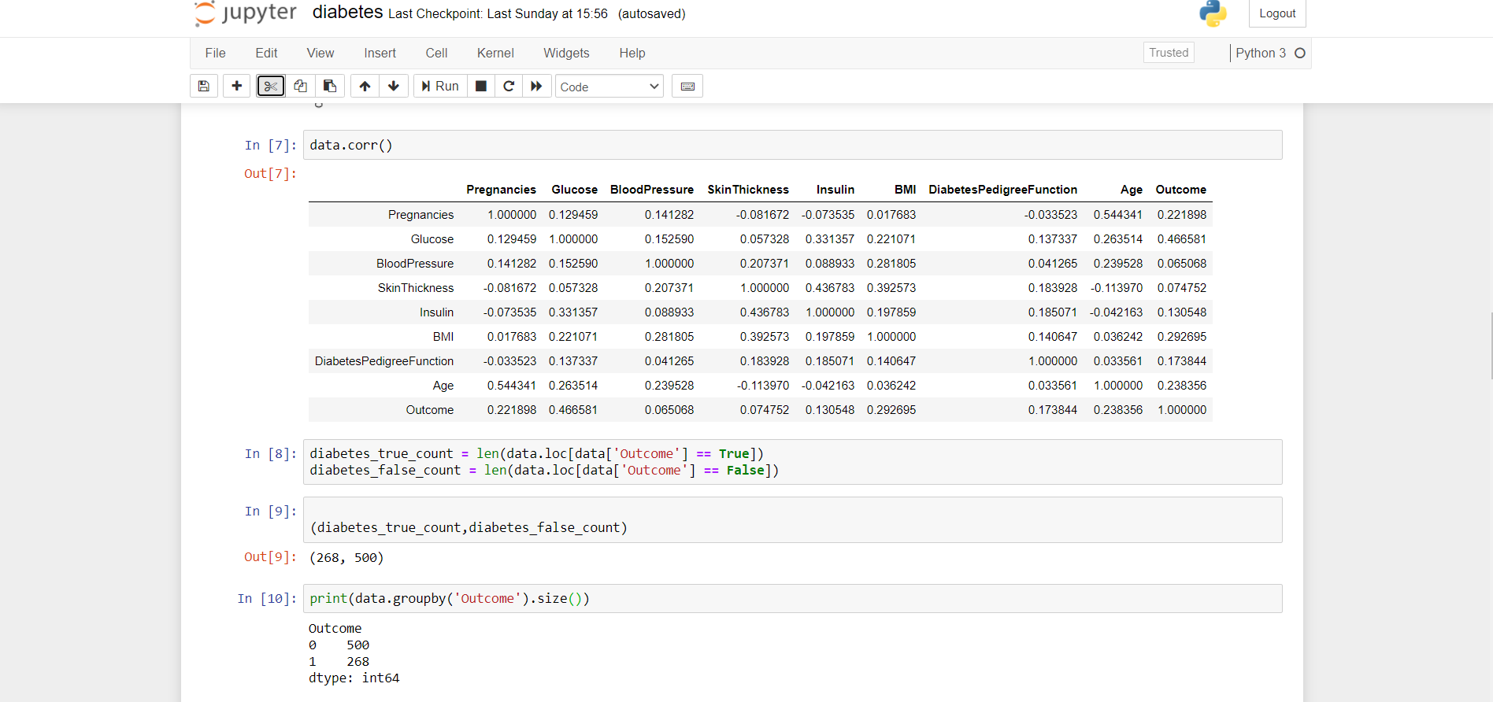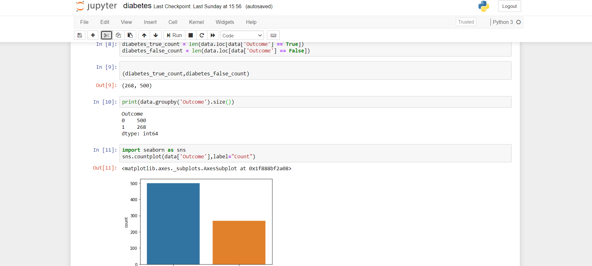

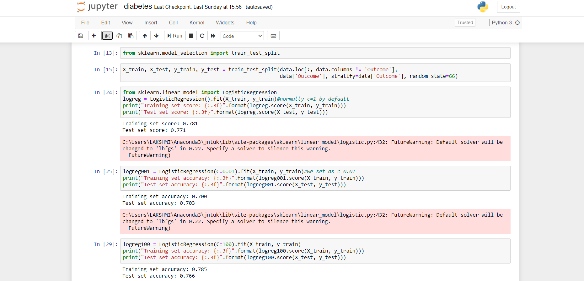

Hence, I got the accuracy as 78% when I trained the dataset.